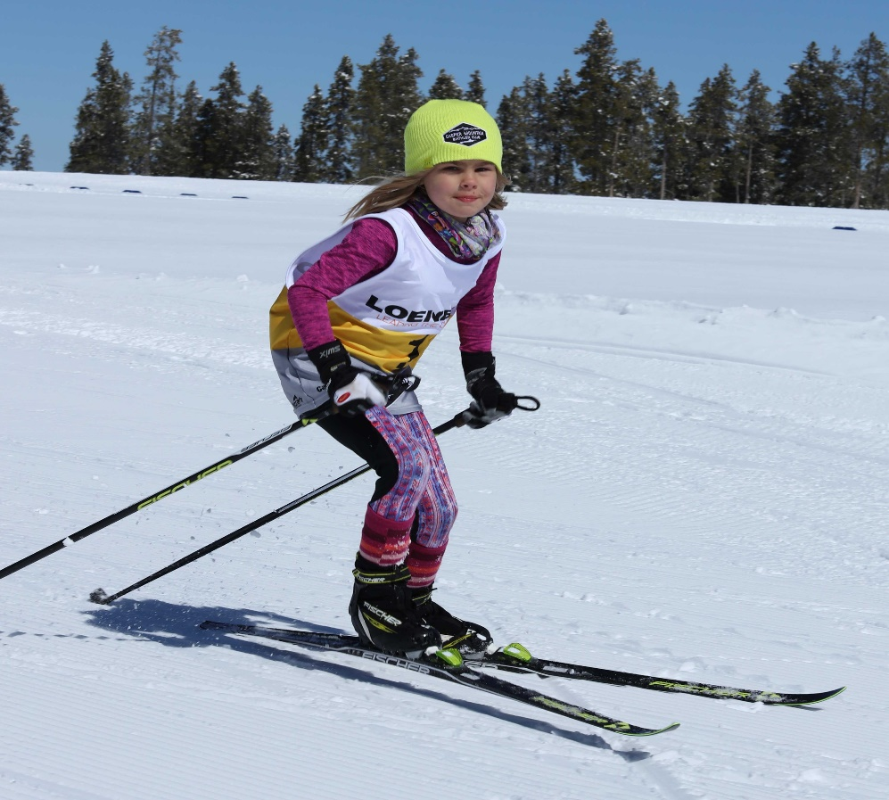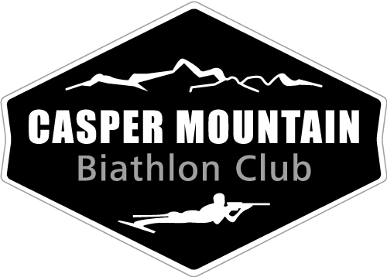

April 14, 2018 | 10:00 AM

Youth Ski Festival  
Casper Mountain, WY | Free!

Cross Country Ski Clinics for beginners | 10 am – 11am  
Biathlon Beginner Clinic | 10 am – 11:00  
Races for Youth 6 – 15 yrs old.  
Races start at 11:30:  
**Novice 1 km Classic race for beginners**  
**Freestyle Categories– Freestyle Race  
U16/U14 12 -15 yrs 3km  
U12 9-11 yrs 2km  
U10 6 – 8 yrs 1km**  
Awards for top 3 boys & girls in each category Location: McMurry Mountain Park. 1110 East End Road.

Register Online at CasperMountainBiathlonClub.org

FREE TRAIL PASSES

FREE SKI EQUIPMENT FOR BEGINNERS AGE 6 – 15 (FIRST 50 REGISTERED)

YOUTH SKI FESTIVAL

U